Therapy Schedule

This website will provide a friendly interface for managing therapies schedule and therapies fees payments.
The app will manage a therapist's schedule and client's bill. The therapist has to set his availability days and hours. The client has to login or create an account to be able to see the therapist schedule and select a time. Also he needs to provide payment information with credit or devit card billed. The app will send an appointment-friendly reminder.

The therapist and his clients will use this site. All the users must be older than 18 years. They can be users of any sexual identity, country, race, and social status.

The application will have a database with 7 tables. One table with therapist’s name, specialty, contact information, and office address. Other table with the patient personal information, First name, last name, date of birth, gender, ethnicity, phone number, email, address. Other table with patient’s emergency contact full name, phone number, and email. Patients user name and password. Othet table with the session information, therapist id, patient id payment id, status, and comments, Other table with the calendar, day, month, time, and status. Othet table with payment information like patient id, amount, date, concept, and card. Another table wit the users login information, user id, username, and password.

Database schema
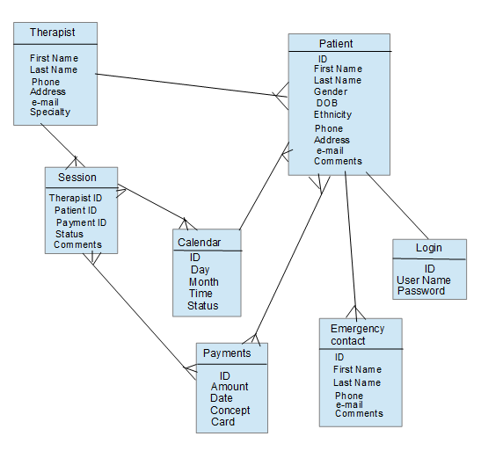
This app will have patient confidential information and password that needs to be encrypted. The payment transaction will be managed for and external finantian application. The application will keep a table with the basic payment information. The patient and the terapist will be able to check the payments.

The payment transacction could be the challengin operation ecause it is sensitive information and it will be a conection with and external application. The app will manage CRUD through PSQL, autentication, and email app.

The main page will contain a NAVBAR with two options Login or Singin, an the website description, services, and terapist avaliables.
The Login botton will take the pattient to the calendar with the terapist avalability, where the patient will select a day and time to schedule a therapy, to confirm the terapy will have to provide a payment information. After the payment verification an e-mail appointment confirmation, information, and payment recip will be sended.
The singin botton will take the patient to another page to provide his personal information, and create a user name and password. (On this parth may will validate the e-mail acount provide by the patient with a verification e-mail).
The therapist will have to sing in to manage sessions, update the appointments calendar, and check payments.

